Worksheet 1 Recursive algorithms
Task 1

1. Write pseudocode for a recursive routine to find the sum of all the even numbers between 0 and n. Show how the subroutine would be called and the result output.

2. Trace through the following program. How many times is the recursive routine called? What is output?
Note: numbers[1:] is the list of numbers starting at index 0, i.e. if numbers = [3,6,2,8] then numbers[1:] = [6,2,8]

SUB addNums(numbers)
IF length(numbers) > 1 THEN
numbers[0] = numbers[0] + addNums(numbers[1:])
ENDIF
OUTPUT (numbers[0])
RETURN numbers[0]
ENDSUB

marks = [3,6,2,8]
total = addNums(marks)
OUTPUT ("Total = ", total)

numbers | length(numbers) | numbers[0] | Output
[3,6,2,8] | 4 | 3 + addNums([6,2,8])
[6,2,8]
 |  |  | 8

Task 2
3. A tree is shown below.
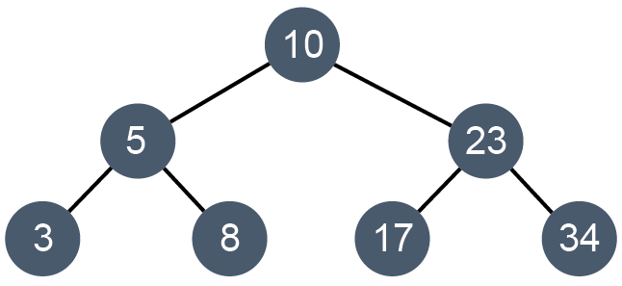
(a) The tree can be represented as a table as shown below. Complete the table to show all left and right pointer values.

 | left | data | right
tree [0] | 1 | 10 | 3
tree[1] |  | 5
tree[2] |  | 3
tree[3] |  | 23
tree[4] |  | 34
tree[5] |  | 8
tree[6] | -1 | 17 | -1

(b) The subroutine for a traversal is shown below. In what order are the nodes output?
SUB traverse(p)
IF tree[p].left <> -1 THEN
traverse(tree[p].left)
ENDIF
OUTPUT tree[p].data
IF tree[p].right <> -1 THEN
traverse(tree[p].right)
ENDIF
ENDSUB
(c) Write a subroutine for a post-order traversal.

4. (a) Operators and operands in a mathematical expression can be added to a tree in such a way that when the tree is traversal using a post-order traversal, an expression is produced in postfix notation. This transformation is typically done during compilation of a program.
Show the output of the following tree when the post-order traversal is performed.
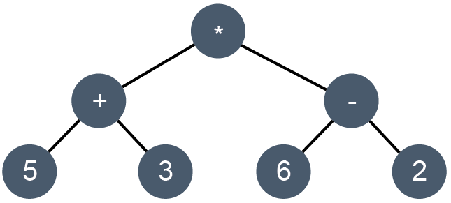

(b) An expression in prefix notation is produced when the tree is traversed using the following traversal algorithm:

visit the root node
traverse the left subtree
traverse the right subtree

Show the output of the tree when the pre-order traversal is performed.

(c) Perform an in-order traversal and hence evaluate the expression.

